**Experiment -5 3d text using blender**

[**https://drive.google.com/file/d/1jHCMFSciUStXCq9AeMRjH2KGkwhFlmgh/view?usp=sharing**](https://drive.google.com/file/d/1jHCMFSciUStXCq9AeMRjH2KGkwhFlmgh/view?usp=sharing)

**Step 1:**Shift A and Add text. Click**“**Shift + A**”**from the keyboard a list opens on the screen select “Text” option from there.

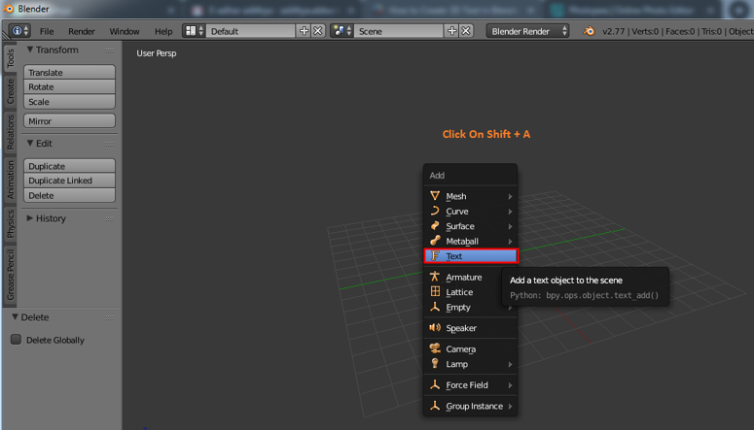

A default text and curser will be created by blender after selection. Tab key from a keyboard that helps in changing the text to text mode and solid mode as required, to edit the text select text area and click the tab. Curser directly gets highlighted at the corner as the text same as window word now we can click backspace or select complete text at once and delete it. Type the text which must be appeared as required.

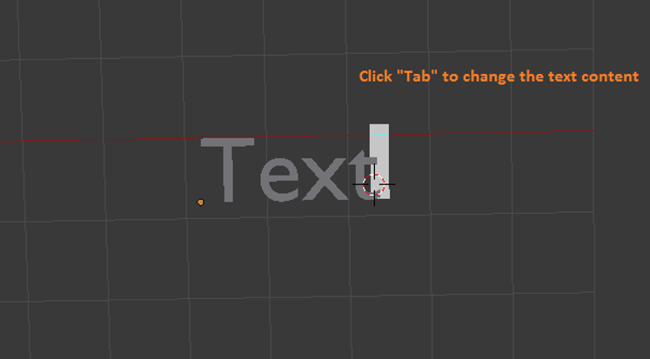

**Step 2:**After filling the required text in the area click TAB the text mode changes to object mode. Now we need to learn a few basics of Blender such

Pan = Shift + middle mouse button

* Move = axis + right click-drag to move objects
* Rotate = Hot key R
* Scale size = Hot key S
* Selection = Left mouse click
* Rotate view = mouse center button and move mouse.

These keys help in creating and moving objects and viewing them in different angles.

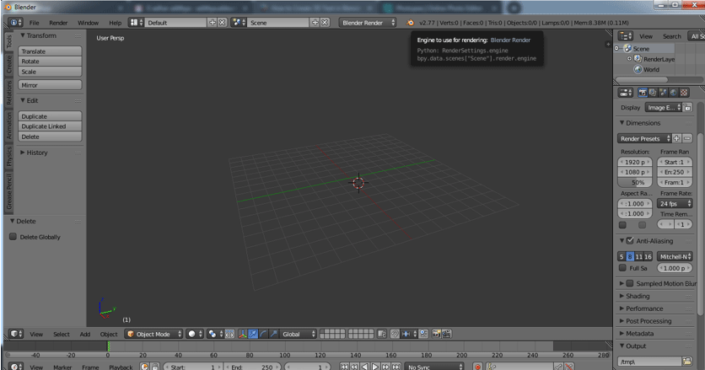

**Step 3:**Select text and click “Tab” to get text mode on.

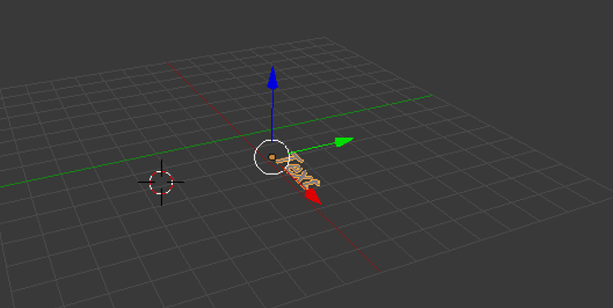

Type text needed and remove unwanted words or letters as to how we do in the windows word file.

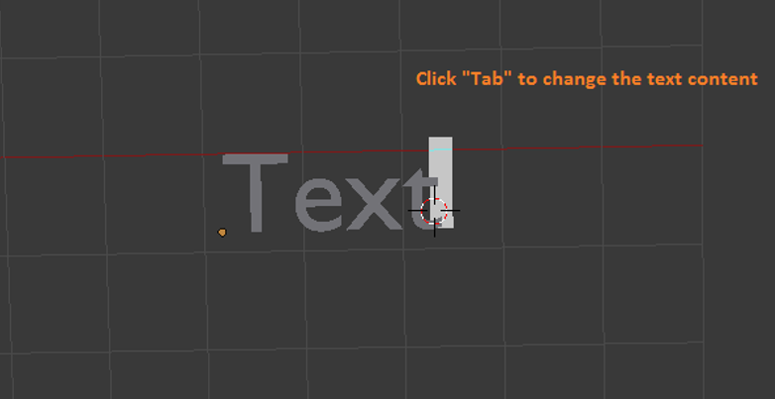

Once after typing the word apiaries on the screen and click “Tab” to make it object then move it to the center of the grid.

**Step 4:**3D text excludes can be done in as shown below.

Select exclude and give the required value of excluding height required to the text.

We can even maximize the window by lift clicking and selecting Maximizing option or use Ctrl Up Arrow and Down Arrow to increase and decrease the values.

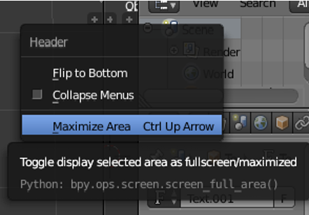

From the left pane, we can maximize and select the “**F**” icon to get all Text and Front related attributions for our text selected.

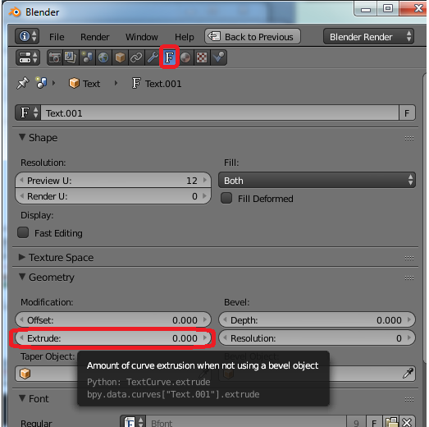

**Step 5: Rotate Text**

Till now our text was flat with on the grid now let’s make the text visible from the front view (let’s wake it up).

Go to rotate options and on X-axis give the value as 90 degrees. The text changes its orientation as shown.

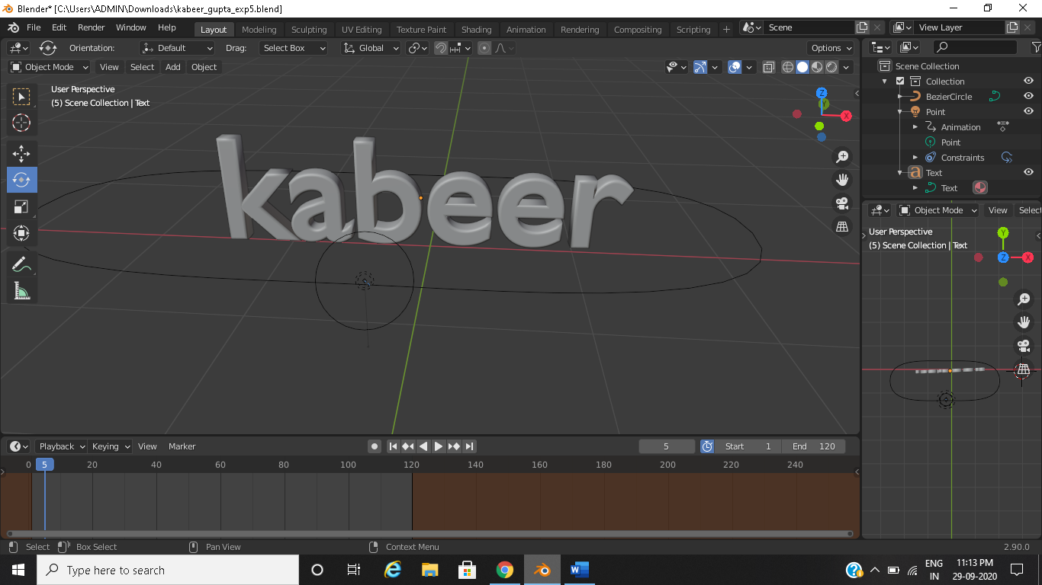

**Step 6:**Go to the Fronts layer in the left panel for all text-related attributions on the pane.

Front -> click on Load a file (Folder symbol)

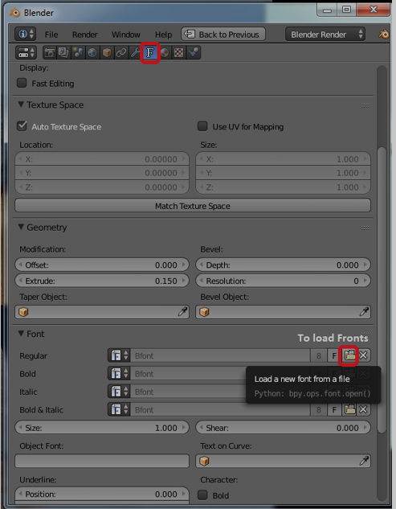

A Blender file browser opens then clicks on C drive

C drive -> click on windows folder

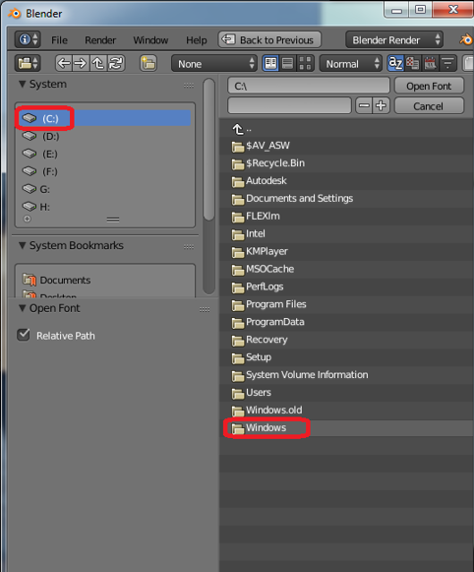

C: – windows -> select Fonts folder

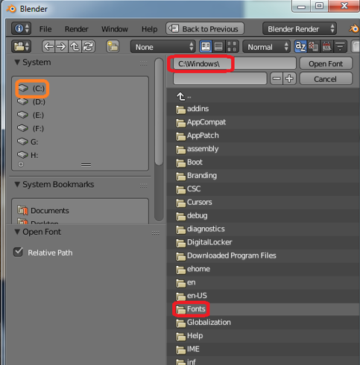

C:\windows\fonts all the default blender installation access fonts will be available here.

Many online plug-ins are also available to [use in Blender](https://www.educba.com/what-is-blender/) to have unique title styling. The application contains all most all the fronts by default.

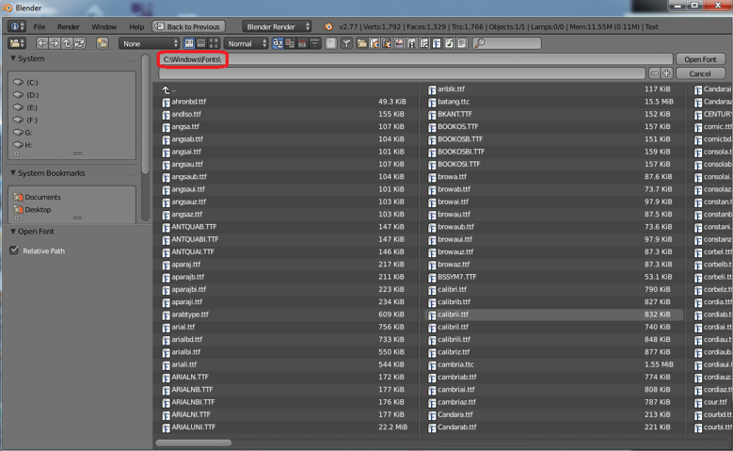

**Step 7:**After applying appropriate front to the text then on left pane we have 2 options Level and Bevel. Both help in shaping the corners of the text if there are too sharp at corners.

**Step 8:**Adding resolution adds curviness and a smooth radius to the corner of the text.



**Step 9:**Click on render option on the top right corner of the application screen to have a rendered view of the text.



Adding and positioning Camera and lighting also play a key role to show the view of the text made and its shadow details